
BMS College of Engineering
Department of Information Science and Engineering
Capstone Project – AY- 2022-2023
Batch No: 26 | Project Title: Air quality monitoring, forecasting and controlling system using IoT and Data Science

Team Members
SL.No. | USN | Name of the Student | Email | Mobile No.
1. | 1BM19IS117 | Prateek M Gummaraju | prateekm.is19@bmsce.ac.in | 8762412587
2. | 1BM19IS133 | Ruchi Agarwal | ruchi.is19@bmsce.ac.in | 9670922221
3. | 1BM19IS219 | Samartha S | samarthas.me19@bmsce.ac.in | 9738473489

ABSTRACT
Air pollution is the presence of compounds in the atmosphere that are hazardous to human beings and the health of other living organisms, or that can impair climate and materials. Chemical compounds such as carbon monoxide, ozone, nitrogen dioxide etc, are common air pollutants and they lower the quality of air.
In many industrial and urban areas today, maintaining and monitoring air quality has become a top priority. Numerous elements, such as time, location, and uncertain variables have an impact on air quality. Due to the rising levels of air pollution, there is a great need to implement effective air quality monitoring systems that gather data on the concentration of various air pollutants and provide not only the current assessments of the level of pollution, but also predict the level of pollution in the near future. In addition to this, we find it essential to compare the pollution levels with the recommended limit given by organizations such as the World Health Organisation (WHO) and consequently provide measures to prevent the same.
With this project we aim to successfully demonstrate the possibility of a low cost, IOT based system built using Arduino and various sensors that not only monitors the current air quality, but also has the ability to forecast the future predictions and also provide suggestions on how to control the pollution and protect human beings from the harmful pollutants.

- INTRODUCTION
  - Background work
As part of our research leading into the project, we went through multiple research papers to understand the current State-of-the-art systems and methodologies for monitoring and predicting the Air Quality. From our research we have come to understand that the Air Quality Index as defined by WHO is segregated into buckets such as Good, Moderate, Poor, Unhealthy, Severe Hazardous.

Source: World Health Organisation

Diving a bit deeper into the current products in the market, we realized that the 3 main reasons the Air Pollution Monitoring systems haven’t been adopted by every organization are:
- High Costs
- Low Awareness
- Bulky Equipment
As part of our project, we aim to solve these 3 issues mainly.

We have also found an open source dataset containing hourly measurements of pollutants in Indian cities from 2015 to 2020 to train our models.

  - Motivation
With 7 million deaths worldwide attributed to air pollution each year, it is currently thought to be the greatest environmental health danger on the planet. Air pollution causes and aggravates a wide range of diseases like asthma, cancer, heart disease etc.
Air pollution is increasing rapidly today, especially in urban and industrial areas primarily due to vehicular emissions, manufacturing facilities and industries accumulating a large number of dangerous pollutants.
Due to the rising levels of air pollution and its adverse effects, there is a great need to implement effective air quality monitoring systems that are accurate and cost effective. We also want our system to forecast the future air quality and also provide suggestions on how to control and reduce the level of pollutants in the atmosphere.

- PROBLEM DEFINITION
The aim of this project is to build a cost effective and efficient air quality monitoring and predicting system using Arduino and various sensors like MQ135 Air quality sensor, MQ131 Ozone sensor, PM2.5 sensor etc. The data collected by the sensors will be uploaded to a server, where it can be used as a test dataset for our model. We aim to build a prediction model using different Machine Learning algorithms such as linear regression, decision tree, random forest etc, and a few Deep Learning algorithms and then choose the best model based on accuracy and error rate. We also aim to benchmark our findings against the recommended limits given by the World Health Organisation and give a few insights on what can be done to stay within the limits. In short, we want to provide a holistic solution.

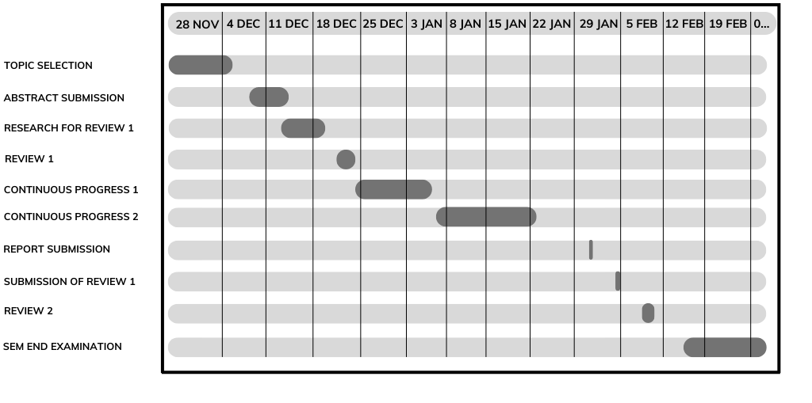
- GANTT Chart

Synopsis : Accepted
Yes | No

Name of the Guide: Pallavi B (Assistant Professor) | Signature of Team Members
Signature of the Guide: | Prateek M Gummaraju  Ruchi Agarwal  Samartha S

